1. Please submit your specifications.
2. Include the main premise of the game.
3. Include any storyline that you might have so far.
4. Include what the game will do/does.
5. Include the types of machines you plan to target (PC, Mac, mobile, web, etc.).
6. General proof of concept like a storyboard; examples of this could be hand-drawn pictures, slides, screenshots, etc.

The main premise of my game is that there is this small, cute, person, cartoon character that the player controls. There will probably be a few different versions of the character for players to choose from. Players will be running through different themed levels that will probably feel Mario Bros.-esque. I want the game to be a cute, simple, cartoon, platform game. There will be purple dinosaurs throughout each level that players must avoid in order to not take any damage. There will also be meteors along the way that players will collect. The meteors will be used to throw at the dinosaurs, damaging their health until they are defeated. I’d love to also have small coins along the way to be collected to buy different sorts of helpful things, but I don’t think I’ll get quite that far. The players, as the characters in the game, need to get through each level while staying alive and collecting meteors to defeat the dinosaurs along the way. Players need to destroy all the dinosaurs in order to start the big bang, creating the universe and saving humanity. The game will probably be targeted toward Mac since that is what system I’m running on.

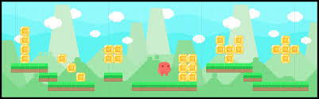 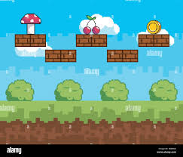

These pictures are good examples of what I picture my game to look like. Simple graphics, platforms for players to run and jump along, cute backgrounds, maybe a few things to collect along the way. I imagine it very simple and cute.

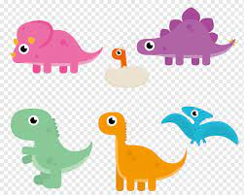 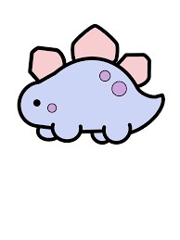 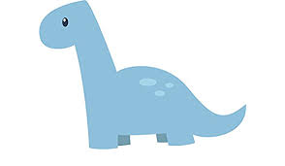

I would love for my dinosaurs to look something sort of like these. I’m good with Photoshop so if I get really ambitious, I could try and make a sprite for the dinosaurs while they’re roaming.

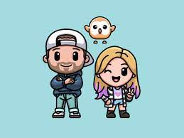 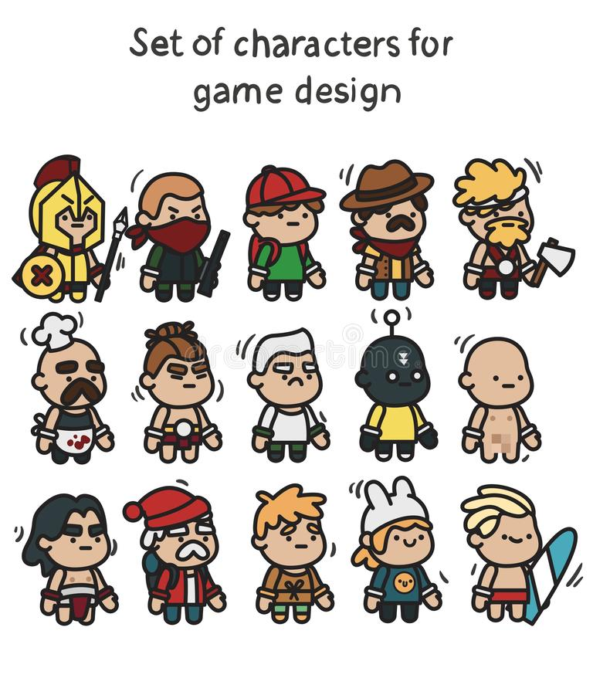 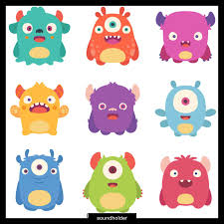

For character inspiration I was thinking maybe something along the lines of these. The cute characters are exactly the look I’m thinking of, I think the middle variations of different characters is a really fun idea. I like the simplicity of these character variations as well. I also saw this picture of the monsters and thought that could be a fun character choice depending on how adventurous I’m feeling with the characters.